MASTER CHIEF

DAVID J. DOLPHIN

Command Master Chief

Training Center Yorktown

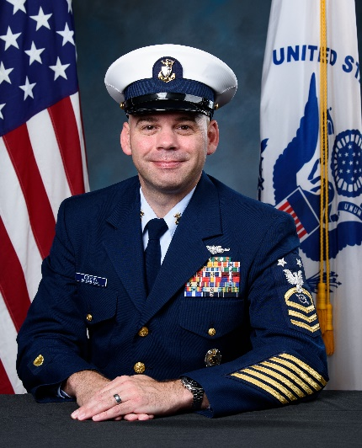
Master Chief Dolphin assumed the role of Command Master Chief of the U.S. Coast Guard Training Center Yorktown in July 2022. As the senior enlisted leader, Master Chief advises the command on the general well-being of service personnel to improve the quality of life for them and their families.

Master Chief grew up in Philadelphia, PA where he began his military career with the Marine Corps Reserves as an Infantryman from 1999 to 2005. Following his end of enlistment with the Marine Corps, Master Chief enlisted in the Coast Guard in 2005.

Master Chief Dolphin is a proud graduate of Operations Specialist “A” School in Petaluma, CA. Upon graduation from “A” school, he served as a Communications Watchstander and Boarding Officer onboard CGC RESOLUTE (WMEC 620) in St. Petersburg, FL (2006-2008); Combat Information Center LPO and Communications LPO onboard CGC MELLON (WHEC 717) in Seattle, WA (2008-2010); Communications Chief and Command Duty Officer (CDO) onboard Sector Long Island Sound, New Haven, CT (2010-2013); Senior Operations Supervisor onboard CGC HARRIET LANE (WMEC 903) in Portsmouth, VA (2013-2015); Command Center Supervisor and CDO onboard Sector Northern New England in South Portland, MA (2015-2018); Sergeant’s Major Course student onboard Ft. Bliss, TX (2018-2019); and most recently, Master Chief served as the Command Master Chief for the Maritime Force Protection Unit in Kings Bay, GA.

Master Chief Dolphin is a graduate of the Coast Guard Boarding Officer Academy class 12-07, Chief Petty Officer Academy class 188, the Senior Enlisted Leadership Course class 47, and the U.S. Army Sergeants Major Academy class 69. He holds an Associate’s degree in Administrative and Management Studies, a Bachelor of Professional Studies degree in Business Management and a Master’s of Science in Management degree from Excelsior College. Master Chief also holds a Bachelor of Arts degree in Leadership and Workforce Development from the U.S. Army Command and General Staff College.

Master Chief Dolphin’s military decorations include three Coast Guard Commendation Medals, three Coast Guard Achievement Medals, the Iraqi and Kosovo Campaign Medals, the Navy Combat Action Ribbon, and the Coast Guard Permanent Cutterman Insignia along with various other decorations and awards.

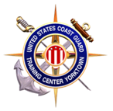
Master Chief is married to Nikita Godette from Guyana, South America. He has one daughter – Deanna, and one grandson Donovan who reside in Killeen, TX, and one stepdaughter, Nia.

